*LTM (Local Travel Mate)*

Namwoo Kim  
knw0809@gmail.com

United UK

Abdullaev Farkhodjon

abdullaevfarhodjon@gmail.com

United UK

Habibilloh Erkinov

habibilloherkinov@gmail.com

United UK

***Abstract- This paper explain LTM (Local Travel Mate) technical and usage. LTM – this application is made for traveler. Much travelers want to travel with local. Much locals also want to meet foreigner. However it is difficult. This application is solution from that problems. We considered how to select the day that is to meet for being more exactly and easier. At that result, we use board function and chat function. By using this application, users can meet people who is users want to travel more easier than last day*. (***Abstract***)**

# Introduction (*Heading 1*)

The main theme of this application is making credible appointment between Traveler and Local. These days, human being travel more than last day. Then, traveler who want to travel with locals is increasing. Many locals also want to make other country friends for exchanging language. But through common way ,it is difficult that meet other country friends. So we started to made this application for matching more easier between local and traveler.

# Local Travel Mate

This Mobile application stand for to support the idea of increasing tourism, giving a most cultural experience to tourists and widening the horizon of local people about other countries, variance cultures and traditions.

The application provide authorization which means login, logout and sign up functions for two different kind of users which are tourists and hosts: -tourists are the users who want to travel to some countries meanwhile the hosts are the local people of that countries. Application requires users to give exact, valid and trustful information about themselves with welcoming status for their profiles when they are signing up and fulfilling their personal information. For developing this Mobile application Android studio and Firebase (Firebase is non relation database system) are needed to store the user information, provide authorization and supply communication between users.

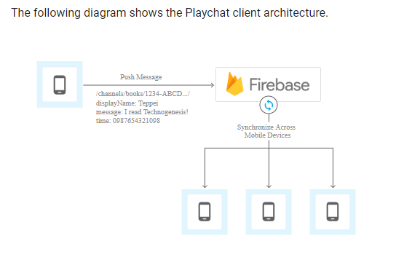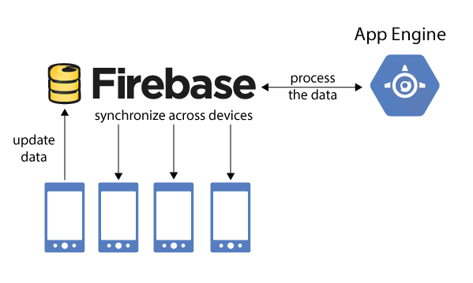

After installing the application, user will be directed to welcoming page which has login and sign up button and also forgot password label. If user is new for this application they can sign up or login or reset their password by going to sign up, login or forgot password page using two buttons and label which we mentioned before.

.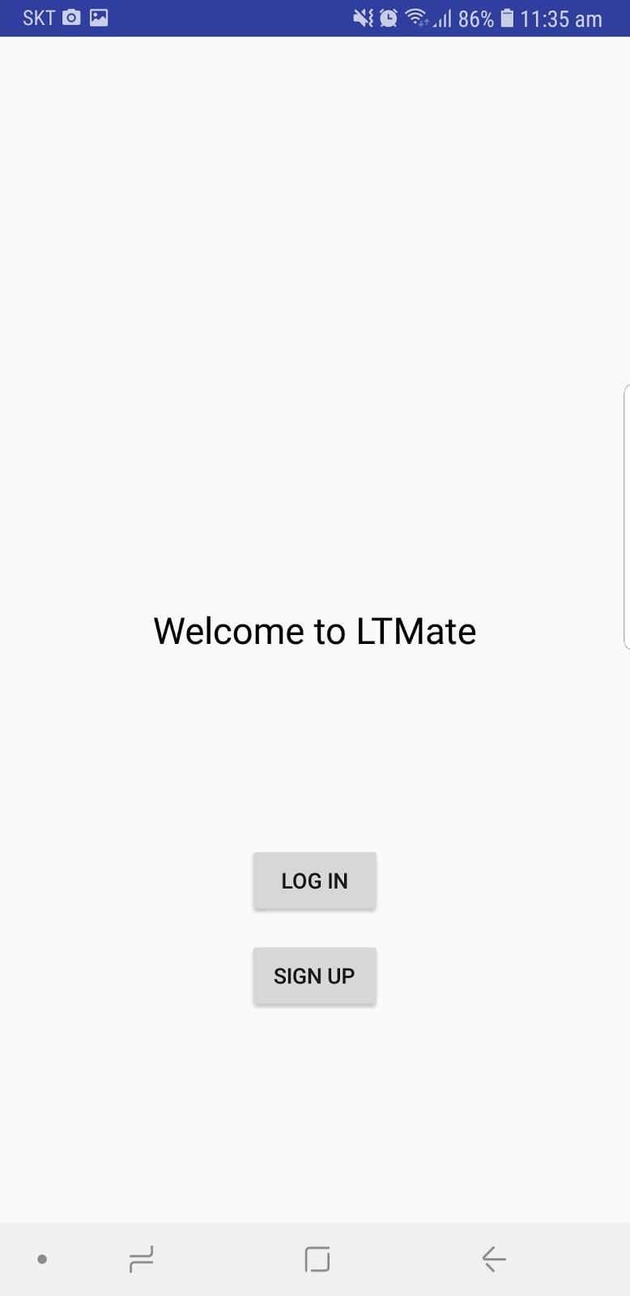 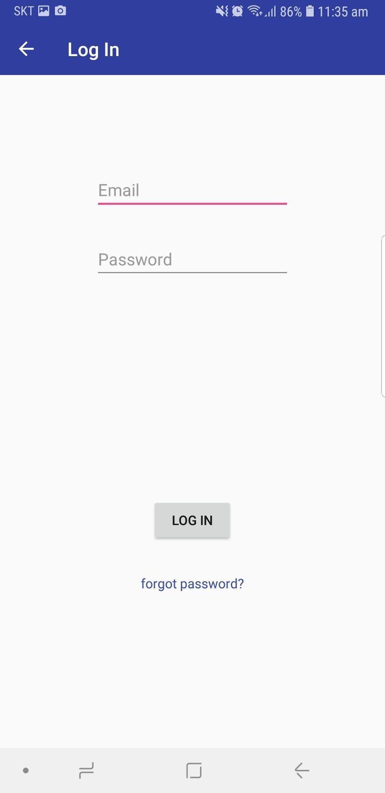

Authorized users will be turn to select country page where they will be faced to list of countries after they choose the country for travel, they will require to insert the travel date which are entry and departure dates (inserting travel date is for only tourists). If users want to change their personal information or travel dates, they can modify it from their profile page.

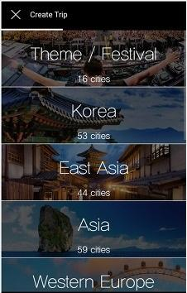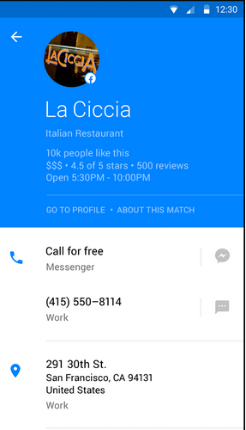

Application provide board page which allows users to upload posts about that they are traveling some countries and looking for local people who live in that countries or hosts who want to invite tourists to their area by uploading images and information about the place.

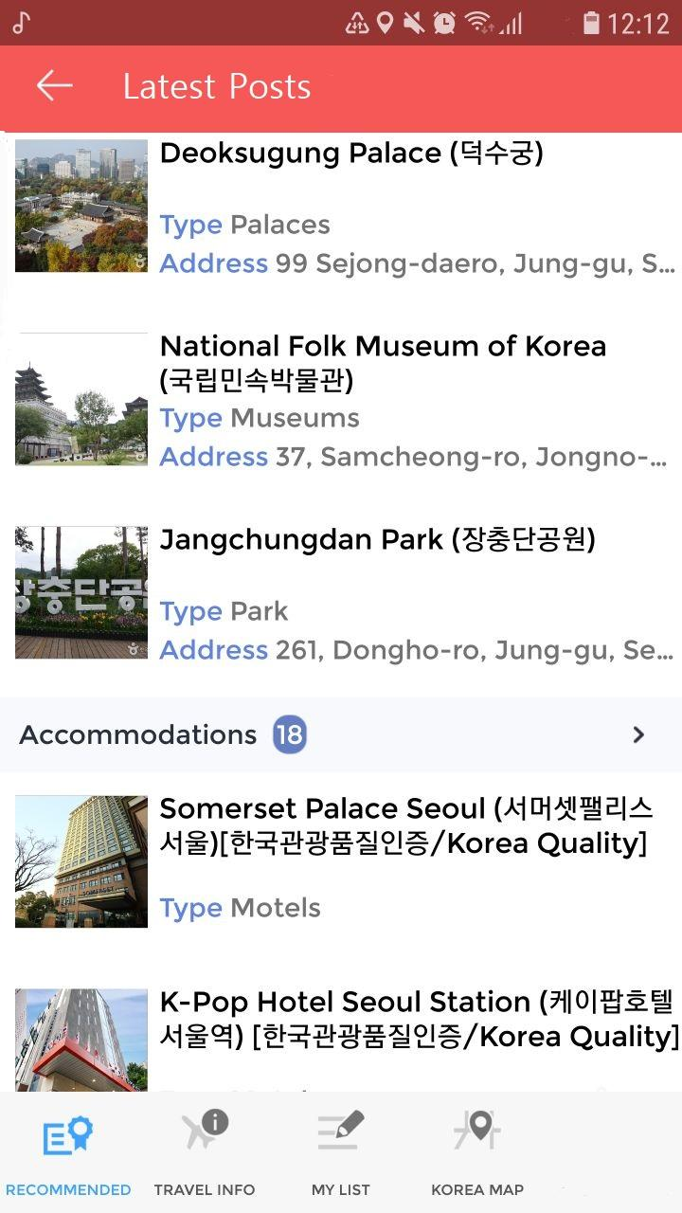

* Chat page is one of the most useful facilities for users which have been provided by this application. Chat page has three fragment inner pages which are requests, chats and friends pages. If a tourist or host find some useful information on board page, they can easily contact with the person who upload the post by sending friend request to him or her. If request is excepted they will be added friend lists of each-other. Then they can open chat room and communicate.
* 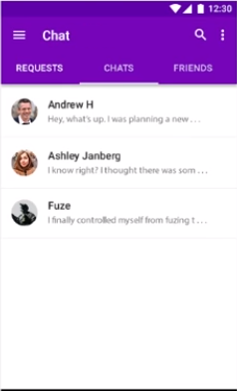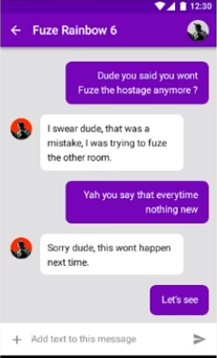
* 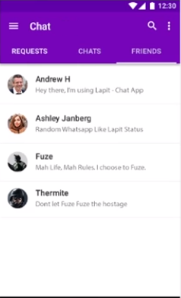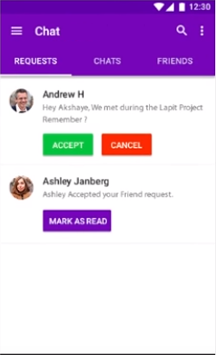

# Conclusion

In summary, the definition and the demonstration of the application shows that, it will be a widely used mobile app among the people as a kind of communication tool as well as being a very good tour guide for the users. The application brings more comforts for the user with its easy usage to understand and easy to find information about the country that the user wants to travel. The user can select any country that he/she wants to travel and get the information about that country's culture, tradition, the touristic attractions, foods, hotels, living expenses and so on. As well as getting information the country before they visit, they will be able to find some friends there those can be guides for them on that targeted country. Furthermore, users or the guides of the host countries can post their good memories or tourist attractions in the news board of the application to attract more people to their country and improve the tourism.

##### References

1. <https://firebase.google.com/docs/>
2. **IEEE conference templates contain guidance text for composing and formatting conference papers. Please ensure that all template text is removed from your**